Allocate Items

Turn on/off and settings

To turn allocation on sign in to your company admin account and go to Settings > control assets - https://www.warp-it.co.uk/company-account/settings/assetsettings.aspx
Scroll down to the Allocate Items section and switch to Enabled and click save changes.
This will open up the allocate section.

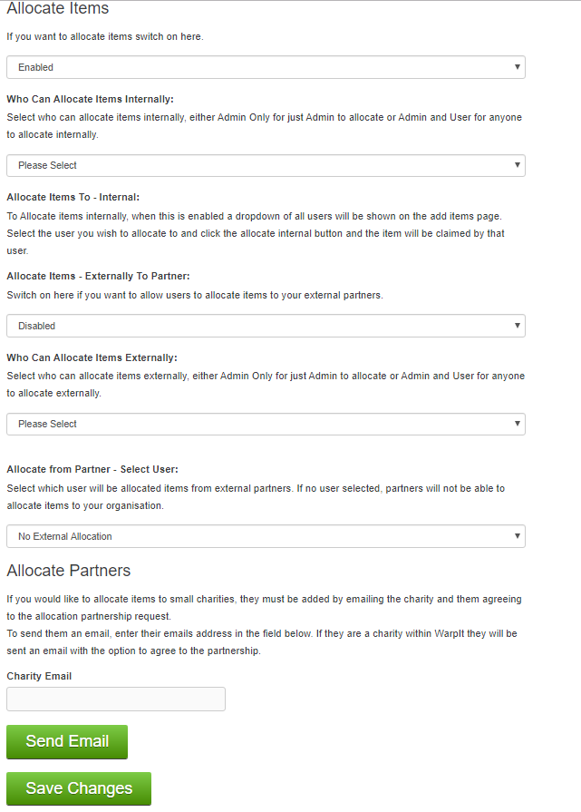

Internal Allocation
From here you can select who can allocate internally by using the Who Can Allocate Items Internally: drop down (Admin only or Admin and User).
External allocation
You can switch On/Off allocate external by switching Allocate Items - Externally To Partner: between enabled and disabled.
You can select who can allocate externally by using the Who Can Allocate Items Externally: drop down (Admin only or Admin and User).
Allocation User – From External
Clicking on the Allocate from Partner - Select User: drop down will list all your users, click on the user you want partners to allocate items to.
If left as No External Allocation or Allocate Items - Externally To Partner is disabled, the option for your partners to allocate to your
organisation will not appear on their add items page.
Click save changes after you have selected your option to confirm.
Allocate Partners
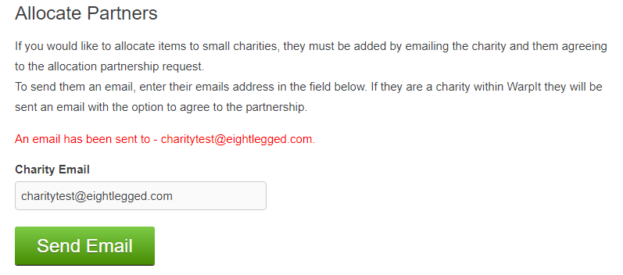
This is to allocate items to charities. To add a charity to the list, first enter the email that uses for Warp It login.
This will send an email for the charity to confirm the partnership.
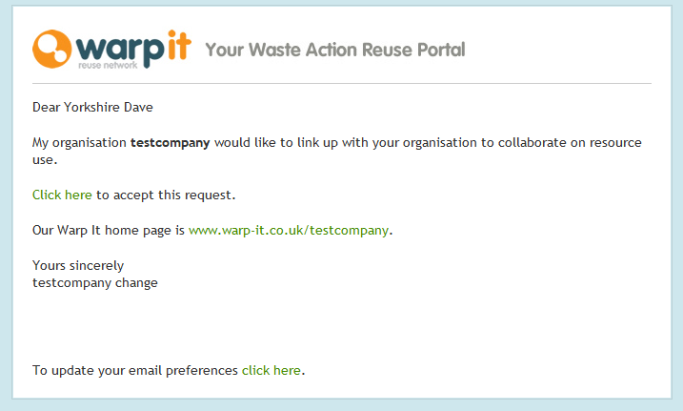
Clicking accept will goto a page with this message.
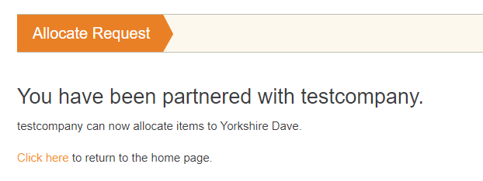
When the charity has confirmed they will appear on a list of partnered charities.
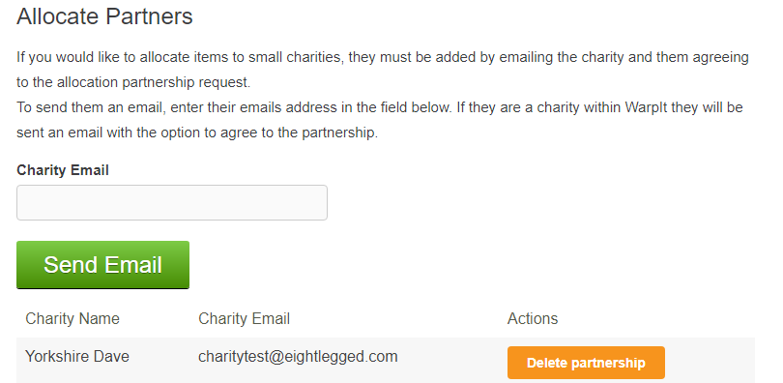
This is the list that will appear on the add item page in allocate Charity section.

Allocate items to charity

To allocate to charities. After filling in the item details and selecting the partner charity from the dropdown list, clicking the allocate charity button
will add the item as normal but the partner charity will be allocated the item as a claimed item.
The item owner and the allocated charity will be notified by email of the transaction.
Either can then set the claim as delivered/collected to complete the transaction
or cancel the claim and then the item will then go live as an item that has been added as normal.

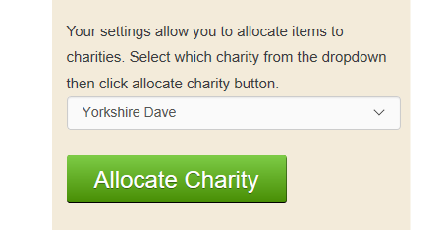

Add items page

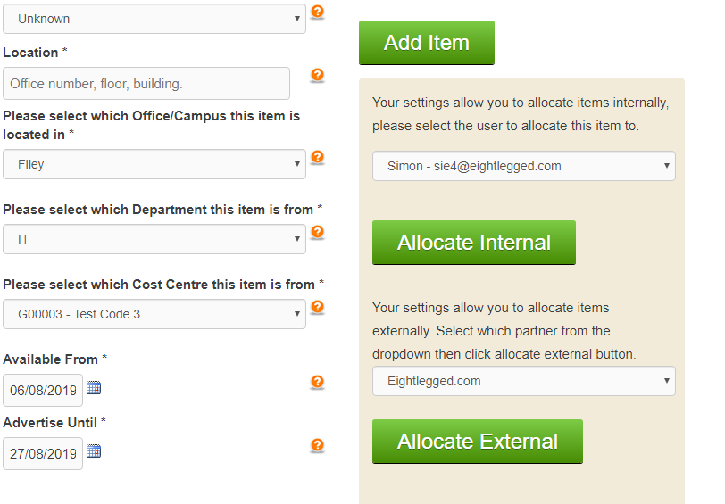

Internal

A list of all internal users will be available if Allocate is switched on.
After filling in the item details and selecting the user from the dropdown list, clicking the allocate internal button
will add the item as normal but the internal allocation user will be allocated the item as a claimed item.
The item owner and the allocated user will be notified by email of the transaction.
Either can then set the claim as delivered/collected to complete the transaction
or cancel the claim and then the item will then go live as an item that has been added as normal

External

For the allocate external button to appear one or more of your partners must have an
Allocate Items To – From Partner user selected and have allocate external enabled.
For each partner that has an external user, their organisation name will appear in the drop down.

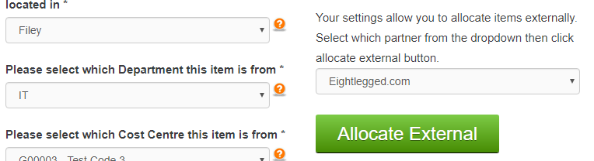

After filling in the item details, clicking the allocate external button will add the item as normal but the external allocation user will be allocated the item as a claimed item.
The item owner and the allocated user will be notified by email of the transaction. Either can then cancel the claim and then the item will then go live as an item that has been added as normal.

All allocated items can be viewed after the transaction by going to the claimed items page. From here the claim can be completed or cancelled.

Allocate items retrospectively

To allocate retrospectively go to the active items list view and select the item you wish to allocate. This will open the edit item page, if allocate is switched on the allocation section will appear. To allocate item replicate the steps on the add item page.
